Samuel Lipscomb Seckham
2

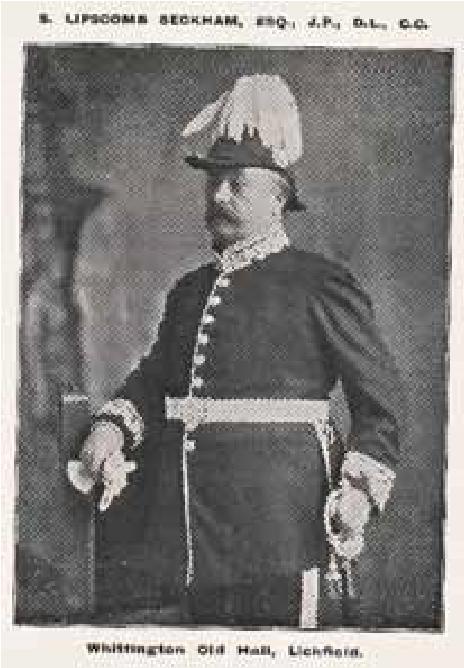
The Seckham family moved to Longdon in the early 1870s. Samuel Lipscomb Seckham was trained as a carpenter, bricklayer, and stonemason, and in the 1860s made his fortune as a city surveyor and architect. He worked in Oxford, where he built the Park Town Estate, the Corn Exchange, and worked on a number of manor houses. He invested wisely and became Chairman and Managing Director of the Northampton Brewery and founded the Northampton Electric Light and Power Company. Interestingly, he also purchased Bletchley Park, which, later, famously became the base for the World War 2 code breakers.

Rather than living in Northampton, Samuel moved the Seckham family to Longdon near Lichfield Staffordshire, renting Hanch Hall from the Forster family. The connection between the two families would become stronger, when, in 1876, Francis Villiers Forster married Samuel’s sister, Harriet.
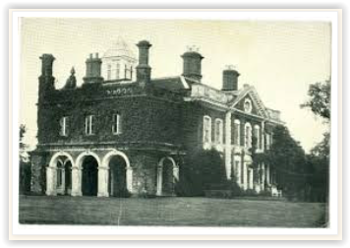
Seckham had married Kinbarra Swene Smith, from Walsall, in 1853. They had seven sons and five daughters, and the last four of these children were baptised at St. James’s church, Longdon

Hanch Hall

.
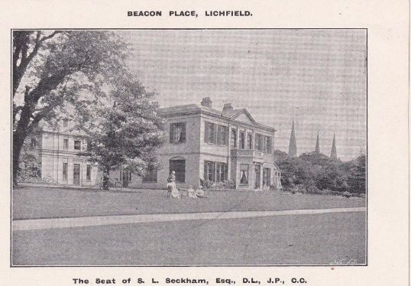
In 1880 Samuel bought, and began renovating, Beacon Place, a very large mansion house in Lichfield. The grounds are now Beacon Park. In 1889, he purchased Whittington Old Hall. He became a Justice of the Peace and Deputy Lieutenant and represented Lichfield on Staffordshire County Council.
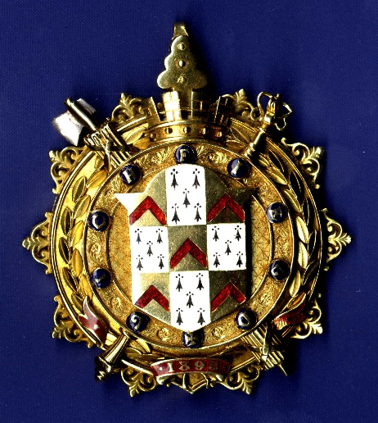

In 1897 he presented the Chain of Office, for the Sheriff of Lichfield now wear each year by the current Sheriff.
“Presented to the Corporation of Lichfield”
S. L. Seckham
J.P. + D.L. Justice of the Piece + Duoty Lefttenanbt
A Citizen of Lichfield
Made by the Birmingham goldsmiths T. & J. Bragg and hallmarked 1895

He made significant alterations and improvements to Christ Church in Leamonsley Lichfield, and when he died in 1901, his funeral was large, and he was much mourned. Seckham Road, near Beacon Park, commemorates his impact on the area.

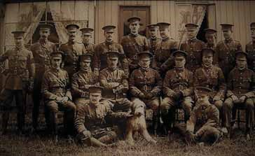
Three of Seckham’s children had distinguished careers as army officers; Bassett Thorne, Douglas Thorne and Guy Lipscomb Thorne. They were also members of the South Staffordshire hunt, and regulars at Longdon Grange.

Bassett and Douglas both fought in campaigns in South Africa in 1900-1901. Bassett was made Colonel, mentioned in despatches, awarded the Queens Medal and created a Companion of the Distinguished Service Order.
Basset and Douglas Thorne (4th and 5th from left in middle seated row) with other officers at Whittington Barracks

All three would offer their services at the outbreak of the First World War in 1914, and were involved with the recruitment and training of troops at Whittington Barracks, particularly with the South Staffordshire Regiment’s 4th Battalion. The 4th were sent to Jersey to train, with Colonel Basset as Commanding Officer and Lieutenant-Colonel Douglas as second-in-command.
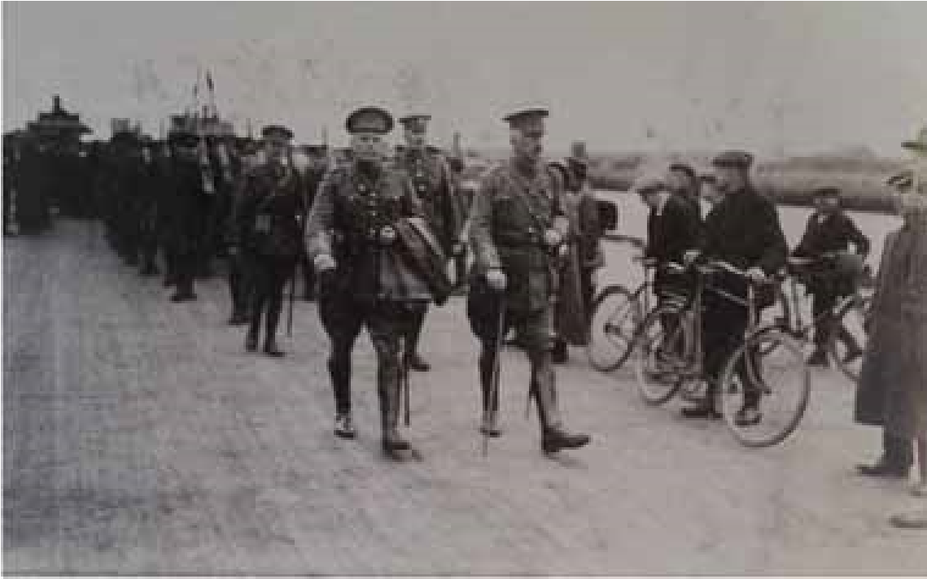
On 22nd March 1915, Douglas left Jersey to take command of the 7th South Staffordshire Battalion who had lost all of its commanding officers in trench warfare. He remained with them for the next two years as the Battalion engaged in many major battles in France and Belgium. He was wounded in June 1917, near the Belgian village of Wytschaete, during heavy shelling, and was brought home. He was awarded a Distinguished Service
Order in 1917 New Year’s Honours.

Lt.-Col Douglas Seckham (centre) leading troops in Jersey

Douglas Seckham retired back to country life, with his wife, Helen Christobel Cairnes, an Irish heiress, and their daughter, Gillian. The family had a house in Lisnegar, Rathcormac, County Cork, and split their time between Ireland and Longdon. His brother, Guy, was living in Longdon Green, and, it would seem that, between 1918 and 1930, when Douglas’s family were in Longdon, they either resided in Longdon Green or Longdon Grange.

In March 1930, Francis Villiers Forster died, aged 80, of chronic bronchitis. In his will, he left his pack of hounds to Douglas Seckham, as well as the ownership of Longdon Grange, providing he would agree to be Master of the Hunt, and so the Grange became the official seat of the Seckhams.

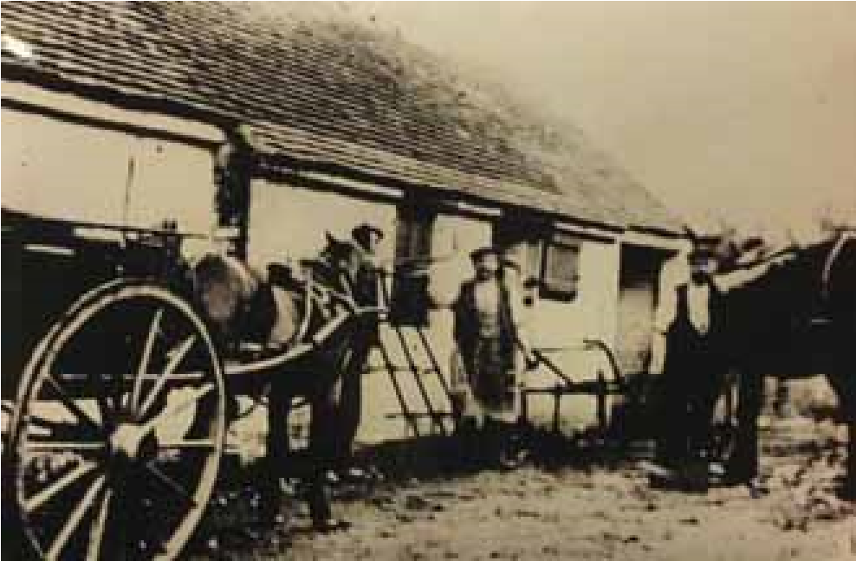
Helen Seckham, meanwhile, became an equally important member of the village community. She was very involved with the early years of Longdon’s Women’s Institute, held several important positions, and, in 1936, was one of the four trustees who purchased the Old Forge for
£60, which is still used as the W.I. Hall to this day.

In 1937, Douglas Seckham died suddenly at the Grange. Although Helen would continue to live at the Grange for another ten years, hosting garden fetes in the grounds, and being heavily involved in Longdon W.I., Douglas’s death marked an end to the Grange being at the centre of activity for the South Staffordshire Hunt.

